ONEWAY CS BY RES
/STATISTICS DESCRIPTIVES HOMOGENEITY WELCH
/PLOT MEANS
/MISSING ANALYSIS.

Oneway

Notes
Output Created |  | 06-May-2019 00:04:05
Comments
Input | Active Dataset | DataSet0
Input | Filter | <none>
Input | Weight | <none>
Input | Split File | <none>
Input | N of Rows in Working Data File | 30
Missing Value Handling | Definition of Missing | User-defined missing values are treated as missing.
Missing Value Handling | Cases Used | Statistics for each analysis are based on cases with no missing data for any variable in the analysis.
Syntax |  | ONEWAY CS BY RES  /STATISTICS DESCRIPTIVES HOMOGENEITY WELCH  /PLOT MEANS  /MISSING ANALYSIS.
Resources | Processor Time | 00 00:00:00.156
Resources | Elapsed Time | 00 00:00:00.178

[DataSet0]

Descriptives
 | N | Mean | Std. Deviation | Std. Error | 95% Confidence Interval for Mean
 |  |  |  |  | Lower Bound | Upper Bound
1360x768 | 7 | 39.4286 | 1.51186 | .57143 | 38.0303 | 40.8268
1920x1080 | 15 | 38.4000 | 2.77231 | .71581 | 36.8647 | 39.9353
800x600 | 8 | 37.5000 | 4.24264 | 1.50000 | 33.9531 | 41.0469
Total | 30 | 38.4000 | 3.00115 | .54793 | 37.2794 | 39.5206

Descriptives
 | Minimum | Maximum
1360x768 | 36.00 | 40.00
1920x1080 | 33.00 | 40.00
800x600 | 28.00 | 40.00
Total | 28.00 | 40.00

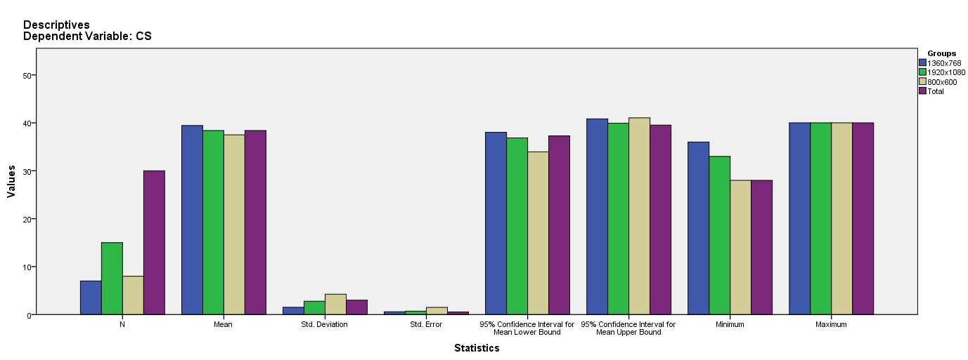

Test of Homogeneity of Variances
CS
Levene Statistic | df1 | df2 | Sig.
2.967 | 2 | 27 | .068

ANOVA
CS
 | Sum of Squares | df | Mean Square | F | Sig.
Between Groups | 13.886 | 2 | 6.943 | .758 | .478
Within Groups | 247.314 | 27 | 9.160
Total | 261.200 | 29

Robust Tests of Equality of Means
CS
 | Statisticª | df1 | df2 | Sig.
Welch | 1.059 | 2 | 14.641 | .372
a. Asymptotically F distributed.

Means Plots

